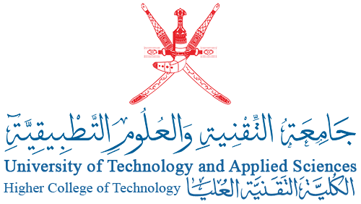

**Executive Summary**

Based on the objectives of Oman 2040 vision regarding the development of higher education institutions’ practices, and the requirements of the OAAA regarding the improvement of institutional work in various educational institutions, this report aims to propose a comprehensive quality management system for the University of Technology and Applied Sciences. It aims to do this through an in-depth review of the quality departments' policies and procedures in the various colleges of technology (CoTs) and colleges of applied sciences (CAS) and to compare them with their counterpart Omani and international higher education institutions. The University of Technology and Applied Sciences quality management system will outline structural changes to enable more efficient quality assurance practices with clearer roles, responsibilities, authorities, policies and procedures. During the review, special attention was paid to involve stakeholders and to incorporate the outcomes of the conducted benchmarking.

1. Sur College of Applied Sciences.
2. Salalah College of Applied Sciences.
3. Sohar College of Applied Sciences.
4. Ibri College of Applied Sciences.
5. Nizwa College of Applied Sciences.
6. Rustaq College of Education.
7. Muscat Higher College of Technology
8. Al Musanna College of Technology.
9. Ibra College of Technology.
10. Ibri College of Technology.
11. Nizwa College of Technology.
12. Shinas College of Technology.
13. Salalah College of Technology